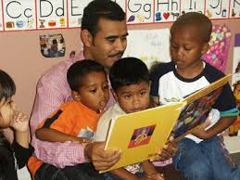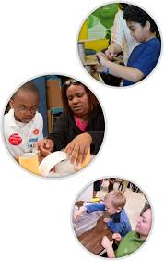
Focus on Families
Family Resource Center

Toddler Play Time Group
Niagara Street School, Room C125
Includes structured activities,
Child-directed play, story time, crafts, and snacks
Please Feel Free to Join Us!

Program Begins on Thursday, September 17th, 2015 at 9am

Programs are for children 18months-4yrs & their parents, grandparents, or guardians. Transportation may be available.
Please call Margaret at 716-286-0777 or 716-807-8902 to register or for further questions.
Please enter through Main door and sign in at the office

